## Pandit Deendayal Energy University, Gandhinagar School of Technology

**Department of Computer Science & Engineering**

**Computer Network Lab**

**(20CP301P)**



# **Name:** Ravi Jamanbhai Makwana

**Enrolment No**: 21BCP418

**Semester**: 5

**Division**: 6 **Group:** G12

# **Branch:** Computer Science

**Experiment-1**

**Part A**

**Aim:** Simulation of Various Networking Topologies

**Prerequisite:** Nil

**Outcome:** To impart knowledge of Computer Networking Technology

**Theory:** In Computer Network, there are various ways through which different components are connected to one another. Network Topology is the way that defines the structure, and how these components are connected to each other. Network topologies describe the methods in which all the elements of a network are mapped. The topology term refers to both the physical and logical layout of a network.

The arrangement of a network that comprises nodes and connecting lines via sender and receiver is referred to as Network Topology. The various network topologies are:

* Mesh Topology
* Star Topology
* Bus Topology
* Ring Topology
* Hybrid Topology

1. **Mesh Topology:**

The mesh topology has a unique network design in which each computer on the network connects to every other. It is developing a P2P (point-to-point) connection between all the devices of the network. It offers a high level of redundancy, so even if one network cable fails, still data has an alternative path to reach its destination.

**Advantages:**

* The network can be expanded without disrupting current users.
* Need extra capable compared with other LAN topologies.
* No traffic problem as nodes has dedicated links.

**Disadvantages:**

* Installation is complex because every node is connected to every node.
* It is expensive due to the use of more cables. No proper utilization of systems.
* Complicated implementation.

1. **Star Topology:**

In the star topology, all the computers connect with the help of a hub. This cable is called a central node, and all other nodes are connected using this central node. It is most popular on LAN networks as they are inexpensive and easy to install.

**Advantages:**

* Easy to troubleshoot, set up, and modify.
* Only those nodes are affected, that has failed. Other nodes still work.

**Disadvantages:**

* If the hub or concentrator fails, attached nodes are disabled.
* Cost of installation of star topology is costly.
* Heavy network traffic can sometimes slow the bus considerably.

1. **Bus topology:**

Bus topology uses a single cable which connects all the included nodes. The main cable acts as a spine for the entire network. One of the computers in the network acts as the computer server. When it has two endpoints, it is known as a linear bus topology.

**Advantages:**

* Cost of the cable is very less as compared to other topology, so it is widely used to build small networks.
* Famous for LAN network because they are inexpensive and easy to install.

1. **Ring Topology:**

In a ring network, every device has exactly two neighbouring devices for communication purpose. It is called a ring topology as its formation is like a ring. In this topology, every computer is connected to another computer. Here, the last node is combined with a first one.

This topology uses token to pass the information from one computer to another. In this topology, all the messages travel through a ring in the same direction.

**Advantages:**

* Easy to install and reconfigure.
* Adding or deleting a device in-ring topology needs you to move only two connections.

**Disadvantages:**

* The troubleshooting process is difficult in a ring topology.

1. **Hybrid Topology:**

Hybrid topology combines two or more topologies. You can see in the above architecture in such a manner that the resulting network does not exhibit one of the standard topologies.

For example, as you can see in the above image that in an office in one department, Star and P2P topology is used. A hybrid topology is always produced when two different basic network topologies are connected.

**Advantages:**

* Offers the easiest method for error detecting and troubleshooting
* Highly effective and flexible networking topology
* It is scalable so you can increase your network size

**Procedure:**

1. Open Cisco Packet Tracer and simulate the topologies of required size.
2. Assign the IP Addresses to the system.
3. Check the connectivity between the devices.

**Part B**

**Steps:**

1. Select the devices you want to use in your topology after opening Cisco Packet Tracer application.
2. Create the network topology by connecting the devices using the appropriate cables.
3. Configure all the devices with appropriate settings like IP Addresses and Subnet Mask.
4. Test the connections between devices in the network topology by pinging their IP Addresses or by stimulating sending message between them.

**Output:**

**Point to Point Topology:**

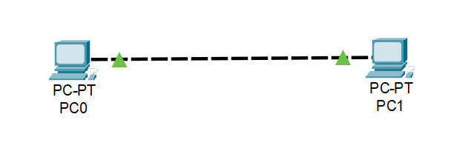

**Star Topology:**

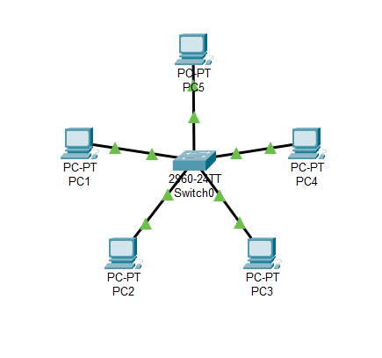

**Mesh Topology:**

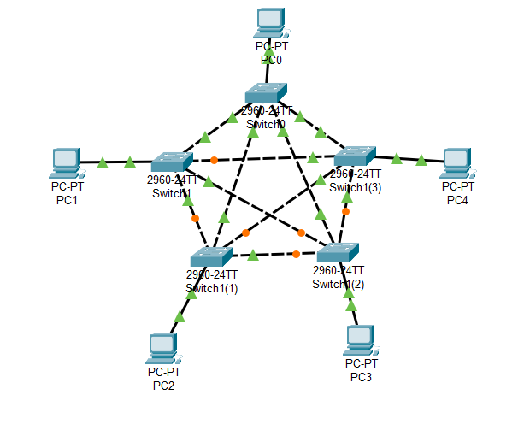

**Bus Topology:**

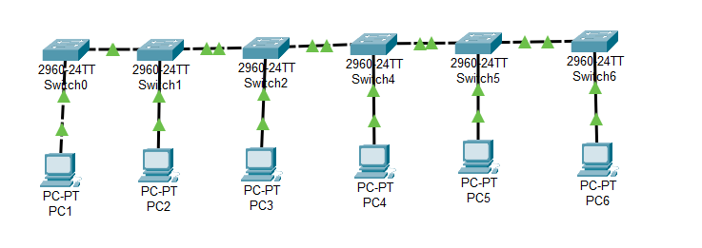

**Ring Topology:**

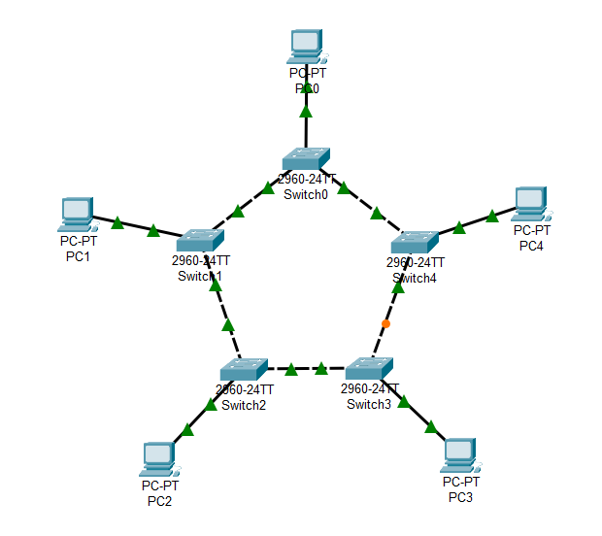

**Extended Star Topology:**

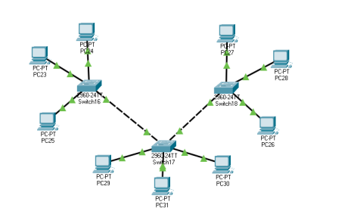

**Hybrid Topology:**

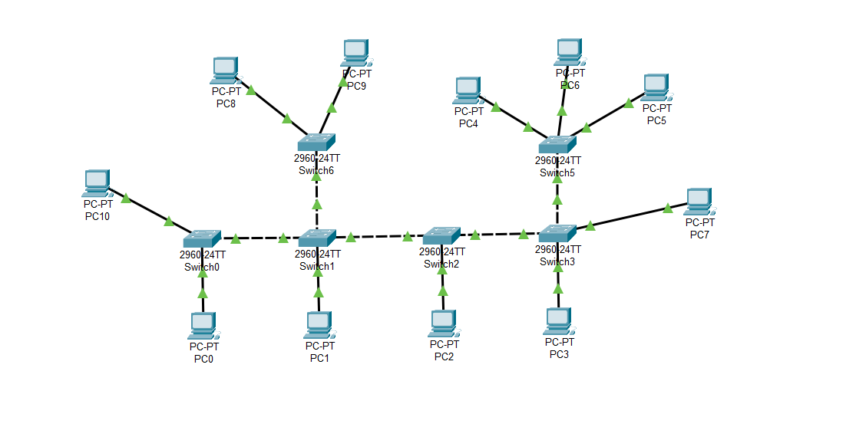

**Observation & Learning:**

We observed the simulation of various network topologies and learnt about their working. In star topology, the devices are connected to a central switch/hub. In bus topology, devices are connected to a single main cable. In ring topology, devices are connected in a closed loop. In mesh topology, each device is connected to every other device. Hybrid topology is a combination of two or more different topology types.

**Conclusion:** The simulation and analysis of various networking topologies, including star, bus, ring, mesh, and hybrid configurations, using Cisco Packet Tracer have provided a comprehensive understanding of their characteristics and implications.

**Questions:**

**1. Which is the most efficient topology in LAN environment and why?**

**Ans:** The star topology is often considered one of the best choices for LAN (Local Area Network) environment, due to its centralized control, ease of troubleshooting, and ability to isolate network issues. Star topologies can provide consistent and predictable performance. Since data traffic travels directly between the device and the central hub, there is less contention for network resources compared to other topologies like bus or ring. If a single device or connection fails in a star topology, only that specific device is affected. Other devices on the network continue to function without interruption. However, different topologies like bus or ring might be more suitable for specific scenarios. It is important to consider the specific requirements of your LAN environment before determining the most efficient topology.

**2. How we can test the connectivity between the terminals?**

**Ans:** We can test the connectivity between the terminals of the network in Cisco Packet Tracer using ping command. Select one of the terminal devices and open command terminal using it in the application. After opening the command terminal, type ping command and the IP Address of the other terminal device with space in between. Now, hit Enter and check if the message is transferred between the terminals or not with the packet losses in between.

**3. What are the two categories of cable? In what type of connection, they are used?**

**Ans:**

a. Ethernet Cables (Twisted Pair Cables)

b. Fiber Optic Cables

Copper and Fiber Optic cables are used majorly in networking devices. Here, Copper cable is used to transfer data between devices of short distance like in the Local Area Network (LAN). Copper cables use electric signals to transmit data while Fiber Optic cables use light to transmit data. Due to this reason, Fiber Optic cables can transmit data way faster than Copper cables. This is why Fiber Optic cables are used to connect devices present in long distances like in WAN and MAN.